Name: Mohamad Haziq Zikry Bin Mohammad Razak

Matric No: A20EC0079

Question 3

3. Write a complete program that calculates the total and the average of marks for any number of subjects taken by a student. The marks are stored in a dynamically allocated array. Basically, the program will perform the following tasks:

i. Prompt the user to enter the number of subjects taken by the student.

ii. Create an array with a dynamically allocated memory to hold the specified number of marks.

iii. Prompt the user to enter the marks for each subject and store them in the allocated array.

iv. Calculate total of the marks.

v. Calculate average of the marks.

vi. Display the output (total marks and average).

vii. Free the allocated memory and make the pointer point to null.

*// Name: Mohamad Haziq Zikry Bin Mohammad Razak*

*// Matric No: A20EC0079*

*// Program that that calculates the total and the average of marks for any number of subjects taken by a student.*

*// The marks are stored in a dynamically allocated array*

#include <iostream>

using namespace std;

int main(){

*// declare variables*

    int num;

    double total, average;

    double *mark;*// dynamically allocate an array*

*// Get the number of subjects taken by the student*

    cout << "Please enter number of subjects taken: ";

    cin >> num;

*//Dynamically allocate an array large enough to hold*

    mark = new double[num];

*// Get the marks of each subject*

    cout << "\nPlease enter the marks of each subject.\n\n";

    for(int i = 0; i < num; i++){

        cout << "Subject " << (i+1) << " :   ";

        cin >> mark[i];

*// calculate the total marks*

        total += mark[i];

    }

*// Calculates the average marks*

    average = total/num;

*// Display the results*

    cout << "\nTotal of Marks:   " << total << endl;

    cout << "\nAverage : " << average << endl;

*// Free dynamically allocated memory*

    delete [] mark;

    mark = 0;*//make mark point to null*

    system ("pause");

    return 0;

}

Output

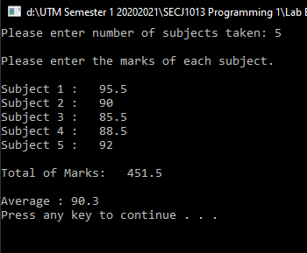

Question 7

What would be the content of each variable at the end of the program segment. The variables: a,b,c, x.y.ax[6], ax[16] and *ip.

#include <iostream>

using namespace std;

int main ()

{

int a = 3;

int b = 8;

int c = 2;

int x = 5;

int y = -5;

int ax[20] = {2,3,1,7,12,35,-6,77,-8,9};

int *ip;

int *ix;

ip = new int[5];

for (a =0;a<5; a++)

    cout << *(ip + a );

*ip = * ax;

ix = ip + 10;

a = *ix;

*(++ix) = *(ax + 6);

b = *ix;

c = *(ax + 6);

x = *ix *= ax[4];

return 0;

}

a = 17042712

b = -6  
c = -6  
x = -72  
y = -5  
ax[6] = -6  
ax[16] = 0  
*ip = 2

Question 8

What is the output of the following program.

*//Program 7.12*

#include <iostream>

using namespace std ;

int* myfunction (int *y) {

    int* px = y ;

    int temp = 12;

    y[4] = y[0];

    y[0]= temp;

    for (int j=0;j<5;j++)

        cout <<y[j]<<" ";

        cout <<endl;

        return px;

}

int main () {

    int* pi, *x;

    int a[]= {3,4,5,6,7};

    x=a;

    pi = myfunction (x);

    cout << "*pi = " << *pi << endl;

    for (int j=0;j<5;j++)

        cout <<a[j]<<" ";

    return 0;

}

***Output***

12 4 5 6 3

*pi = 12

12 4 5 6 3

Question 14

#include<iostream>

using namespace std;

int main()

{

    int *iptr;

    iptr = new int;

    *iptr=50;

    cout<<"The address of iptr: "<<iptr<<endl;

    cout<<"The value of *iptr: "<<*iptr<<endl;

    delete iptr;

    return 0;

}

1. Identify the output of the program

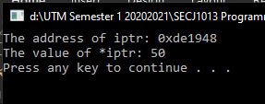

1. Draw the memory layout of the program

|  |  |  |
| --- | --- | --- |
| Memory Address | Identifier | Contents |
| 0xde1948 | iptr | 50 |

Question 15

Type in Program 7.6. Run the program. Determine the output and explain in details the steps involved until the program is terminated.

*//Program 7.6*

*//Using the new and delete operators for Dynamic Memory*

*//Allocation*

#include <iostream>

using namespace std;

int main(){

    int i, num;

    int * id;

    cout <<"Enter number of student:";

    cin >> num;

    id = new int[num];

    for (i=0; i<num; i++){

        cout << "Enter student ID: ";

        cin >> id[i];

    }

    for (i=0; i<num; i++){

        cout << "id for student number " << (i+1) << ": ";

        cout << id[i] << endl;

    }

    delete [] id;

    return 0;

}

Output

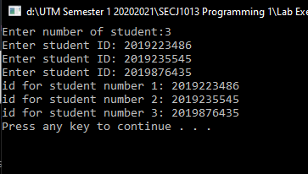

Explanation

In line 8, the variables are declared. In line 9, it dynamically allocates the array. From line 11 to 12, the program gets the number of students and at line 13, it dynamically allocate an array large enough to hold itself. From line 14 t0 16, the program gets the student ID for each student stated and it will go through the for loop. From line 19 to 21, it will display the student ID of each student that was stated. On line 24, it will free the dynamically allocated memory and the program will be terminated.